University Timetable Optimization and Management System
(UTOS)
Software Engineering Project Document
Full-Scope Analysis: Requirements, Use Cases, and System Modeling
Version 2.0 | May 2026

1. Introduction

1.1 Purpose
This document is the Software Engineering project report for the University Timetable Optimization and Management System (UTOS). It serves as the primary analytical and design record for a university-level SE course submission, covering requirements specification, use case analysis, system modeling, and implementation evidence.
UTOS is a web-based platform that automates, optimizes, and manages timetable creation for both weekly class schedules and semester examination periods at full university scale. The system handles the complexity arising from multiple departments, thousands of concurrent users, and a large set of hard and soft scheduling constraints.

1.2 System Overview
UTOS provides two closely related but operationally distinct scheduling subsystems within a unified platform:
- Class Timetabling Module — weekly class schedule generation, conflict resolution, quality review, manual adjustment, locking, re-optimization, versioning, and publication.
- Exam Timetabling Module — examination room management, student hierarchy, exam course association, semi-automatic exam placement, invigilation duty assignment, and exam schedule export.

Both modules share master data (rooms, users, roles, academic terms) and system-wide features including role-based access control, in-app notifications, version comparison, export (PDF/Excel/CSV), audit logging, and a comprehensive reporting suite.

1.3 Problem Statement
Manual timetable creation at university scale is a combinatorial problem of considerable complexity. The specific challenges addressed by UTOS include:
- Class Timetabling: Teacher clashes, room conflicts, section scheduling across dozens of departments, holiday handling, variable class durations (1 h, 1.5 h, 2 h), hundreds of hard and soft constraints, and thousands of enrolled students.
- Exam Timetabling: Multiple exam courses, large student populations, room capacity constraints, varied exam durations, no student double-booking, and invigilation assignment.
UTOS must handle these constraints at full university scale while remaining responsive, usable, and role-appropriate for six distinct user types.

1.4 Document Scope and Organization
This document is organized as follows:
- Introduction and Scope Alignment
- Process Model
- Requirements Summary
- Use Case Analysis — High-Level, Essential, and Real Use Cases
- System Modeling — DFDs, Swimlane, Sequence, ERD, and Architecture
- UI Evidence and Implementation Screens
- Traceability Matrix
- Conclusion and Document Checklist

1.5 Terminology and Conventions
Term | Definition
SuD | System under Discussion — the UTOS web application (frontend, backend API, database, solver, notifications)
Timetable Administrator | Role with full access to timetable setup, generation, review, and publication
Department Coordinator | Role with department-level review, data validation, and change-request approval
Teacher | Role with view and change-request submission access
Student | Role with published timetable view only
Facility Manager | Role with room data maintenance and utilization report access
System Administrator | Role with user account, role, and security management access
Essential Use Case | Abstract, technology-free description of what the actor wants to achieve and why
Real Use Case | Concrete description of current UTOS interface behavior tied to UI screenshots
Hard Constraint | A scheduling rule that must never be violated (e.g., no teacher clash)
Soft Preference | A configurable optimization goal that the solver attempts to satisfy where possible

2. Process Model

2.1 Selected Lifecycle
UTOS uses the Incremental Process Model as its primary development lifecycle, supported by Prototyping for user interface validation. The incremental model was chosen because:
- The system is large and can be meaningfully divided into independently deliverable increments.
- Early increments (master data, constraints, basic generation) can produce a working product that stakeholders review while later increments add exam scheduling, reporting, and scale.
- Risk is reduced because hard problems (solver correctness, constraint logic) are addressed in early increments before the more complex exam and scale features are added.
- UI prototyping allows teachers and students to validate interface designs before backend features are complete.

2.2 Planned Increments
Increment | Module | Focus | User-Visible Value
1 | All | Master data + Academic Calendar | Admin can maintain teachers, rooms, sections, courses, timeslots, semester dates, and holidays.
2 | Class | Hard constraints + basic generation | System enforces no teacher, room, or section clashes; produces a draft timetable.
3 | Class | Soft preferences + quality scoring | Admin configures morning preference, early-end, energy-saving, room proximity, and views quality score.
4 | Class | Review + manual adjustment + locking | Admin inspects, fixes, and locks entries; constraint validation runs on every edit.
5 | Class | Re-optimization + versioning | Approved changes trigger solver repair with locked entries preserved; version history maintained.
6 | Class | Publish + role views | Teachers and students view published schedules filtered to their role and identity.
7 | Exam | Room management + student hierarchy | Exam module foundations: room capacity/type and University to Batch to Section to Student tree.
8 | Exam | Exam scheduling | System suggests exam sessions; admin confirms; no student is double-booked.
9 | System | Background jobs + scale | Long-running generation runs non-blocking; system handles 1000+ concurrent users.
10 | All | Polish + integration | Final integration, UI consistency, export, notifications, audit logs, and reports.

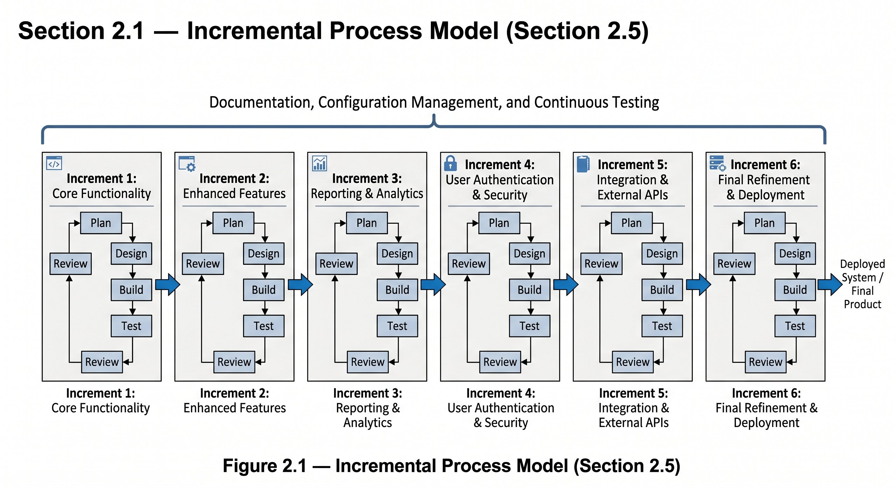
Figure 2.1 — Incremental process model showing planned increments across Class Timetabling, Exam Timetabling, and System-Wide concerns.

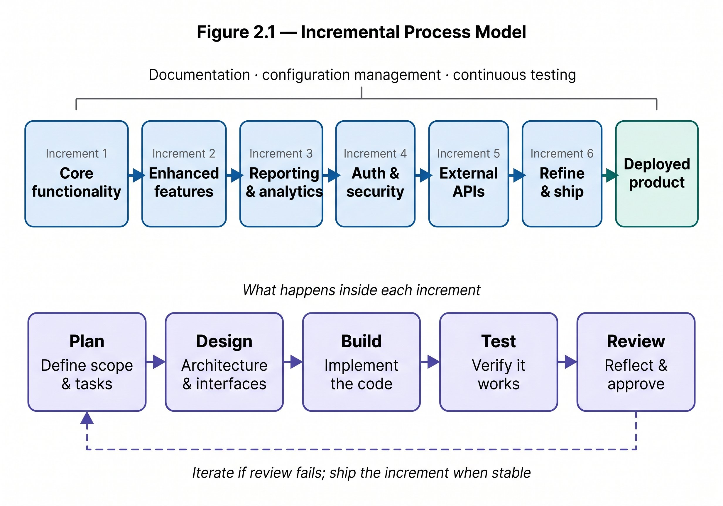
Figure 2.2 — Detail of what happens inside each increment: Plan, Design, Build, Test, Review cycle.

3. Requirements Summary
Requirements are drawn directly from SRS v1.0 Full Scope and summarized here so that use cases and diagrams can cross-reference them by number.

3.1 User Roles and Actors
Role | Login Method | Core Responsibilities
Timetable Administrator | Role selection + password | Full access: setup, generation, review, locking, publishing, versioning, reporting.
Department Coordinator | Email + password | Department data validation, review, change-request approval, quality review.
Teacher | Email + password | View personal timetable, set availability, submit change requests.
Student | Email + password | View published section timetable and exam schedule.
Facility Manager | Email + password | Maintain room data, view room utilization reports.
System Administrator | Email + password | User accounts, roles, security, audit logs, backup configuration.

3.2 Functional Requirements by Module

MODULE 0 — System-Wide Features
Requirement Group | Key Requirements (SRS Numbers)
Authentication and Login | FR-00.1 Admin login by role+password; FR-00.2 others by email+password; FR-00.4 session in localStorage; FR-00.5 session persistence; FR-00.6 logout and password reset; FR-00.6b profile view.
Organization Hierarchy | FR-00.6a University to Faculty to Department; FR-00.6b Batch to Section; FR-00.6c academic terms; FR-00.6d per-term timetable versions.
Export | FR-00.1 PDF (A4); FR-00.2 Excel; FR-00.3 CSV; FR-00.4 all columns included; FR-00.5a/b exam schedule export.
Notifications | FR-00.6 to FR-00.14: generation complete, publish, change-request status, approve/reject, lock/unlock, new version; unread count badge; notification history.
Version Comparison | FR-00.15 to FR-00.19: side-by-side view; added (green), removed (red), changed (yellow) highlights; summary counts.

MODULE 1 — Class Timetabling
Requirement Group | Key Requirements (SRS Numbers)
Academic Calendar | FR-01.1 to FR-01.5: semester start/end dates; holidays; blackout dates; makeup classes for missed sessions.
Master Data | FR-02.1 to FR-02.6b: teachers with max_daily_load; rooms with capacity, type, features; sections with student list; courses with duration (1h/1.5h/2h); 15-minute breaks between slots.
Constraints and Preferences | FR-03.1 to FR-03.15: seven hard constraints (no teacher/room/section clash, capacity, lab rooms, holidays, availability); eight soft preferences (morning, early-end, proximity, energy-saving, traffic, 2-hour class options, holiday maximization).
Generation | FR-04.1 to FR-04.7c: complete draft generation; hard constraint enforcement; soft optimization; unplaced sessions with reasons; background non-blocking execution.
Review and Quality | FR-05.1 to FR-05.5: weekly grid view; hard conflict display; soft penalty breakdown; room utilization; teacher load per day.
Manual Adjustment and Locking | FR-06.1 to FR-06.4: manual entry adjustment with constraint validation; lock/unlock entries; locked entries fixed in re-optimization.
Re-optimization | FR-07.1 to FR-07.3: repair after approved changes; minimize disruption; locked entries unchanged.
Publication | FR-08.1 to FR-08.4b: both coordinator and admin must approve; single published timetable per term; max 10 draft versions; auto-archive beyond 10.
Personal Views | FR-09.1 to FR-09.3: teacher weekly view; student section view; course, room, time, teacher details shown.
Change Requests | FR-10.1 to FR-10.3: teacher submission with optional reason; coordinator review; approved requests trigger re-optimization.

MODULE 3 — Exam Timetabling
Requirement Group | Key Requirements (SRS Numbers)
Exam Rooms | FR-15.1 to FR-15.4: room capacity; room types; optional distance graph; reuse of class-timetable room data.
Student Hierarchy | FR-16.1 to FR-16.4: University to Faculty to Department to Batch to Section to Student tree; bulk import; section-to-course enrollment links.
Exam Courses | FR-17.1 to FR-17.3: course-to-exam association; exam durations (1h, 2h, 3h); course-to-section links.
Exam Scheduling | FR-18.1 to FR-18.8: system suggestions; admin confirm/modify; no student double-booking; room double-booking blocked; capacity check; weekday+Saturday scheduling; 9:00 AM start; 15-minute check-in time.
Exam Views | FR-19.1 to FR-19.5: student exam schedule; teacher invigilation duties; facility manager room usage; PDF and Excel export.

MODULE 4 — System Administration
Requirement Group | Key Requirements (SRS Numbers)
User Management | FR-20.1 to FR-20.8: create accounts; assign roles; RBAC enforcement; self-registration with email verification; bulk Excel/CSV import for students.
System Reports | FR-21.1 to FR-21.8: room utilization; teacher load; conflict summaries; audit logs; late-class report; energy usage; quality score breakdown; section load report.

3.3 Non-Functional Requirements Summary
Category | Key Requirements
Performance | Page load < 1 s; API response < 1 s; timetable generation 5 to 30 min (background); 1000+ concurrent users.
Security | Role-based access control; input validation; audit logging; session management; user-friendly error messages.
Usability | Weekly grid with time-slot columns and day columns; color-coded courses; conflict warnings in plain language; progress indicators; notification badge; side-by-side version comparison; search and filter.
Availability | Published timetable always accessible; version control for drafts; database backup capability.
Maintainability | Modular architecture; swappable solver interface; independent module configurations.

4. Use Case Analysis

4.1 Analysis Approach
Use cases in this document follow the approach described in the teacher-provided Analysis Models guidance (Larman / Jacobson methodology):
- Use cases are defined from actor goals, not from database tables or UI pages.
- High-level use cases provide a brief, structured overview of all major functional goals.
- Expanded use cases are fully dressed with purpose, overview, type, cross-references, typical course of events, and alternative courses.
- Essential use cases remain abstract and technology-free.
- Real use cases describe the current UTOS interface behavior, connected to specific UI screenshots.
- Use case diagrams show actor-use case associations only.
- Include is used only when a behavior segment is genuinely shared by multiple use cases.

4.2 Actors, Goals, and System Boundary
Actor | Type | Goal and Responsibility
Timetable Administrator | Primary | Full access to timetable setup, generation, review, repair, publishing, versioning, and reporting.
Department Coordinator | Primary / Supporting | Validates department-level data, reviews timetable quality, approves or rejects change requests.
Teacher | Primary | Views personal teaching timetable, sets availability, and submits change requests.
Student | Primary | Views the published section timetable and exam schedule.
Facility Manager | Supporting | Maintains room records, monitors room availability, and reviews room utilization reports.
System Administrator | Primary | Manages user accounts, role permissions, security configuration, and audit log access.

4.3 High-Level Use Case Summary
ID | Use Case Name | Module | Primary Actor | Essential Goal
UC00 | Authenticate and Login | System-wide | All users | Select role, enter credentials, and establish a session.
UC01 | Maintain Organization Hierarchy | System-wide | Timetable Administrator | Define university, faculty, department, batch, section, and academic term structure.
UC02 | Maintain Academic Calendar | Class Timetabling | Timetable Administrator | Define semester dates, holidays, blackout dates, and makeup-class windows.
UC03 | Manage Master Data | Class Timetabling | Timetable Administrator | Maintain teachers, rooms, courses, sections, timeslots, room types, capacity, and facilities.
UC04 | Define Constraints and Preferences | Class Timetabling | Timetable Administrator | Configure hard constraints and weighted soft preferences before generation.
UC05 | Generate Class Timetable | Class Timetabling | Timetable Administrator | Create a draft weekly timetable satisfying hard rules and optimizing soft goals.
UC06 | Review Timetable Quality | Class Timetabling | Timetable Administrator | Inspect conflicts, warnings, unplaced classes, quality score, room utilization, and teacher load.
UC07 | Manually Adjust and Lock Timetable | Class Timetabling | Timetable Administrator | Move timetable entries manually and protect selected entries from later solver changes.
UC08 | Submit Change Request | Class Timetabling | Teacher / Coordinator | Request a schedule change through a structured workflow.
UC09 | Approve or Reject Change Request | Class Timetabling | Department Coordinator | Review request details, run conflict check, and decide whether the change is accepted.
UC10 | Re-optimize Timetable | Class Timetabling | Timetable Administrator | Repair the timetable after approved changes while minimizing disruption.
UC11 | Publish Timetable | Class Timetabling | Timetable Administrator | Release the approved timetable as the official live schedule for the term.
UC12 | View Personal or Section Timetable | Class Timetabling | Teacher / Student | View the published timetable filtered to the user role and identity.
UC13 | Export Timetable | System-wide | Timetable Administrator | Export timetable data to PDF, Excel, or CSV for external use or printing.
UC14 | Manage Notifications | System-wide | System / All users | Notify users when generation completes, timetable is published, or requests change status.
UC15 | Compare Timetable Versions | System-wide | Timetable Administrator | Compare two timetable versions side-by-side and identify added, removed, and changed entries.
UC16 | Manage Exam Rooms | Exam Timetabling | Timetable Administrator | Maintain exam room capacity, room type, and availability for exam scheduling.
UC17 | Manage Student Hierarchy | Exam Timetabling | Timetable Administrator | Maintain University to Faculty to Department to Batch to Section to Student data.
UC18 | Manage Exam Courses | Exam Timetabling | Timetable Administrator | Associate courses with exams, set exam durations, and link to taking sections.
UC19 | Schedule Exams | Exam Timetabling | Timetable Administrator | Generate or suggest exam placements while preventing student and room conflicts.
UC20 | View Exam Schedule and Invigilation Duties | Exam Timetabling | Student / Teacher | View exam schedule or invigilation duties filtered to the user role.
UC21 | Manage Users and Roles | Administration | System Administrator | Create and maintain user accounts, assign roles, and control system access.
UC22 | View System Reports and Audit Logs | Administration | Timetable Administrator | Access operational reports and a complete change audit trail.

4.4 Expanded Use Cases
The following expanded use cases are provided for the most important and complex user goals. Each includes both an essential flow (abstract, technology-free) and a real flow (concrete, tied to UTOS screens).

UC00 — Authenticate and Login
Use Case ID | UC00
Use Case Name | Authenticate and Login
Scope | System-wide
Level | User goal
Primary Actor | All users (Timetable Administrator, Department Coordinator, Teacher, Student, Facility Manager, System Administrator)
Supporting Actors | None
Type | Primary, Essential and Real
Stakeholders and Interests | All users require reliable, role-appropriate authentication before accessing any system function. The university requires that access is controlled and auditable.
Preconditions | The user possesses valid credentials. The UTOS web application is accessible.
Postconditions | A session is established in browser localStorage. The user is redirected to a role-appropriate dashboard.
Purpose | Verify identity, establish an authorized session, and route the user to their role-specific interface.
Overview | The login page presents a role-selection control. The Timetable Administrator logs in by selecting the Admin role and entering a password. All other users enter their registered email address and password. On success, a session token is stored and the user reaches their dashboard.
Cross References (SRS) | FR-00.1, FR-00.2, FR-00.2a, FR-00.2b, FR-00.3, FR-00.4, FR-00.5, FR-00.5a, FR-00.5b, FR-00.6

Essential Use Case — Typical Course of Events
# | Actor Action | System Response
1 | This use case begins when a user opens the UTOS application and is presented with a login interface.
2 |  | The system displays a single login page with a role-selection control and credential fields.
3 | The user selects their role and enters credentials.
4 |  | The system validates credentials against stored user records.
5 | The user submits the login form.
6 |  | The system creates a session, stores it for persistence, and redirects the user to their role-specific dashboard.
7 | The user navigates the system using role-appropriate features.
8 |  | The system enforces role-based access control on every request.

Real Use Case — Current UTOS Interface Behavior
# | Actor Action | System Response
1 | This use case begins when the user opens the UTOS URL in a browser.
2 |  | The UI renders a single login page with a role dropdown and credential fields.
3 | The Timetable Administrator selects the Admin role and enters password. Other users select their role, enter email, and enter password.
4 |  | The system validates credentials and returns a session token.
5 | The user is redirected to the dashboard.
6 |  | The UI stores the session in localStorage and renders a role-specific sidebar.
7 | The user selects Log Out from the navigation menu.
8 |  | The system clears the session and redirects to the login page.

Alternative Courses
Line | Alternative / Exception
4a | Credentials are invalid. The system displays a generic error message without specifying whether the username or password was incorrect.
4b | The account is inactive or suspended. The system displays a message directing the user to contact the System Administrator.
6a | The session expires due to inactivity. The system clears the session and redirects to the login page with an expiry notice.
6b | The user clicks Forgot Password. The system sends a password-reset link to the registered email address.

Special Requirements
- Session must persist across browser refresh (FR-00.5). Administrator sessions do not expire on inactivity (FR-00.5b).

Related UI Screenshots
Figure 10.1 — Role-selection login screen.
Figure 10.2 — Role-specific sidebars after login.

UC05 — Generate Class Timetable
Use Case ID | UC05
Use Case Name | Generate Class Timetable
Scope | Class Timetabling
Level | User goal
Primary Actor | Timetable Administrator
Supporting Actors | Solver Engine (internal component)
Type | Primary, Essential and Real
Stakeholders and Interests | Timetable Administrator needs a clash-free, optimized draft to review and publish. Teachers and Students ultimately depend on a well-structured published timetable.
Preconditions | An active academic term is configured. Teachers, rooms, sections, courses, and timeslots have been entered. Hard constraints and soft preferences have been configured.
Postconditions | A new draft timetable version is saved with all placed sessions and a list of any unplaced sessions with reasons. A quality score and penalty breakdown are calculated.
Purpose | Produce a complete weekly class timetable draft that satisfies all hard constraints and optimizes the configured soft preferences.
Overview | The administrator initiates generation from the Schedule Control Center. Generation runs in the background so the administrator can continue using other parts of the system. When complete, the draft is saved as a new version and a notification is sent.
Cross References (SRS) | FR-04.1 to FR-04.7c, FR-00.9

Essential Use Case — Typical Course of Events
# | Actor Action | System Response
1 | This use case begins when the administrator decides to create a new class timetable draft for the current academic term.
2 |  | The system validates that all required master data is present.
3 | The administrator initiates timetable generation.
4 |  | The system starts the scheduling solver and returns control to the administrator immediately (background processing).
5 | The administrator monitors generation progress.
6 |  | The system shows a progress indicator. When complete, it saves the draft, calculates a quality score, and notifies the administrator.
7 | The administrator reviews the generation result.
8 |  | The system presents the new draft version, quality summary, and any sessions that could not be placed.

Real Use Case — Current UTOS Interface Behavior
# | Actor Action | System Response
1 | This use case begins when the administrator opens the Schedule Control Center.
2 |  | The UI displays system status cards and a Generate Draft button.
3 | The administrator clicks Generate Draft.
4 |  | The backend validates master data completeness. If complete, the solver is started as a background job and a generation-in-progress indicator appears.
5 | The administrator continues using other system areas while generation runs.
6 |  | The UI polls generation status. When the solver finishes, the UI shows Generation complete and the notification bell updates.
7 | The administrator opens the generated draft.
8 |  | The UI renders the draft timetable in a weekly grid view. The quality score, unplaced sessions, and penalty breakdown panels are displayed.

Alternative Courses
Line | Alternative / Exception
2a | Master data is incomplete. The system lists the missing items and stops generation before starting the solver.
6a | No complete timetable is feasible. The system saves the partial result and lists every unplaced session with the specific constraint that blocked placement.
6c | Generation exceeds the maximum allowed time. The system saves whatever has been placed, marks the draft as partial, and notifies the administrator.

Special Requirements
- Generation must not block the UI (FR-04.6). The quality score must include a penalty breakdown by constraint type (FR-04.5).

Related UI Screenshots
Figure 10.3 — Schedule Control Center dashboard showing system status cards and the Generate Draft entry point.

UC06 — Review Timetable Quality
Use Case ID | UC06
Use Case Name | Review Timetable Quality
Scope | Class Timetabling
Level | User goal
Primary Actor | Timetable Administrator
Supporting Actors | Department Coordinator, Facility Manager
Type | Primary, Essential and Real
Stakeholders and Interests | Timetable Administrator needs actionable quality information to decide whether to publish, adjust, or regenerate. Facility Manager needs to check room utilization.
Preconditions | A draft timetable version exists (generated via UC05).
Postconditions | The administrator has enough information to proceed to manual adjustment (UC07), re-optimization (UC10), or publication (UC11).
Purpose | Evaluate whether the generated draft is feasible, acceptable, and efficient before committing it for publication.
Overview | The system presents the weekly timetable grid alongside conflict cards, quality score, penalty breakdown, room utilization statistics, and teacher load data.
Cross References (SRS) | FR-05.1, FR-05.2, FR-05.3, FR-05.4, FR-05.5

Essential Use Case — Typical Course of Events
# | Actor Action | System Response
1 | This use case begins when the administrator opens a generated timetable draft for evaluation.
2 |  | The system displays the weekly timetable and a summary of its quality status.
3 | The administrator examines conflicts and warnings.
4 |  | The system shows affected entries and explains each hard conflict and soft penalty in plain language.
5 | The administrator checks quality metrics.
6 |  | The system shows quality score, room utilization rate, teacher load per day, and penalty breakdown.
7 | The administrator decides whether the result is acceptable.
8 |  | The system supports transition to locking, re-optimization, or publication based on the administrator decision.

Real Use Case — Current UTOS Interface Behavior
# | Actor Action | System Response
1 | This use case begins when the administrator opens draft review mode from the Schedule Control Center.
2 |  | The UI shows a Review Mode banner, the weekly timetable grid, a locked/mutable legend, and red conflict cards below the grid.
3 | The administrator clicks a conflict card or highlighted entry.
4 |  | The system reveals which courses, rooms, teachers, or sections are in conflict.
5 | The coordinator reviews department assignments.
6 |  | The system shows filtered department data and report panels.

Alternative Courses
Line | Alternative / Exception
3a | A conflict is unacceptable. The administrator sends the draft to manual adjustment or re-optimization.
7a | The draft has zero hard conflicts but a poor soft score. The administrator may tune soft preferences and regenerate.

Related UI Screenshots
Figure 10.5 — Draft review mode showing padlock icons for locked entries and conflict highlight cards.

UC07 — Manually Adjust and Lock Timetable
Use Case ID | UC07
Use Case Name | Manually Adjust and Lock Timetable
Scope | Class Timetabling
Level | User goal
Primary Actor | Timetable Administrator
Supporting Actors | Department Coordinator
Type | Primary, Essential and Real
Stakeholders and Interests | Timetable Administrator needs fine-grained control to correct specific assignments. Every manual change must be traceable.
Preconditions | A draft timetable version exists. The administrator is in draft review or edit mode.
Postconditions | Selected entries have been moved or locked. The audit log records who made each change and what changed. Locked entries are preserved in future re-optimization.
Purpose | Allow controlled manual editing of timetable entries and protect important assignments from being moved by the solver during re-optimization.
Overview | The administrator selects specific timetable entries to adjust or lock. Each change is validated against hard constraints. Locked entries display a padlock icon.
Cross References (SRS) | FR-06.1, FR-06.2, FR-06.3, FR-06.4, FR-07.1, FR-07.2, FR-07.3

Essential Use Case — Typical Course of Events
# | Actor Action | System Response
1 | This use case begins when the administrator selects an entry to move or protect.
2 |  | The system displays the selected entry with its current assignment and offers alternative room and time options.
3 | The administrator moves the entry to a new assignment or marks it as locked.
4 |  | The system validates the requested change against all hard constraints.
5 | The administrator confirms the change.
6 |  | The system saves the change and records it in the audit log.
7 | Locked entries remain unchanged in any future re-optimization run.

Real Use Case — Current UTOS Interface Behavior
# | Actor Action | System Response
1 | This use case begins when the administrator opens the draft timetable grid in edit mode.
2 |  | The UI renders the weekly grid. Locked entries display a solid padlock icon.
3 | The administrator clicks an entry and selects a new room or time, or clicks the lock icon.
4 |  | The system runs constraint validation. If valid, a green confirmation indicator is shown. If a conflict exists, the system highlights the colliding entry.
5 | The administrator clicks Save.
6 |  | The system saves the updated entry and writes an audit log record.

Alternative Courses
Line | Alternative / Exception
4a | The chosen room is already occupied at the target time. The system rejects the move and shows the conflicting entry.
4b | The target room does not meet the course room type requirement. The system rejects the move and explains the requirement.
4c | The entry belongs to a published timetable. The system requires a new draft version or change-request workflow.

Related UI Screenshots
Figure 10.5 — Draft review/edit mode showing padlock icons and dashed-outline mutable entries.

UC08 — Submit Change Request
Use Case ID | UC08
Use Case Name | Submit Change Request
Scope | Class Timetabling
Level | User goal
Primary Actor | Teacher or Department Coordinator
Supporting Actors | Timetable Administrator (reviewer)
Type | Primary, Essential and Real
Stakeholders and Interests | Teacher needs a formal channel to request a change. Timetable Administrator receives requests for review and action.
Preconditions | The timetable has been published or a draft is under review. The user is logged in with Teacher or Department Coordinator role.
Postconditions | A change request record is created with status Pending. The designated reviewer receives an in-app notification.
Purpose | Provide a structured, traceable mechanism for requesting timetable changes without granting direct editing access.
Overview | The teacher or coordinator completes a request form describing the desired change, the reason, and optionally attaching supporting documentation.
Cross References (SRS) | FR-10.1, FR-10.1a, FR-10.2, FR-10.3; FR-00.10, FR-00.11

Essential Use Case — Typical Course of Events
# | Actor Action | System Response
1 | This use case begins when a teacher or coordinator needs a change to their timetable assignment.
2 |  | The system presents a structured request submission interface.
3 | The requester describes the desired change, states a reason (optional), and may attach supporting documentation.
4 |  | The system validates that the request is associated with a valid timetable context.
5 | The requester submits the request.
6 |  | The system records the request with status Pending and sends a notification to the designated reviewer.

Real Use Case — Current UTOS Interface Behavior
# | Actor Action | System Response
1 | This use case begins when the teacher opens the Change Request Form from their dashboard.
2 |  | The UI renders a form with Subject, Request Summary, Reason (optional), and Attach Document (optional).
3 | The teacher fills in the subject and request summary and optionally adds a reason.
4 |  | The system validates attachment size and type if a document is attached.
5 | The teacher clicks Submit Request.
6 |  | The system stores the request record and displays a confirmation with a reference number.

Alternative Courses
Line | Alternative / Exception
4a | An attached document exceeds the maximum allowed file size. The system rejects the attachment.
5a | The request summary field is empty. The system prevents submission and prompts the user.

Related UI Screenshots
Figure 10.8 — Change Request Form showing Subject, Request Summary, Reason, and Attach Document controls.

UC09 — Approve or Reject Change Request
Use Case ID | UC09
Use Case Name | Approve or Reject Change Request
Scope | Class Timetabling
Level | User goal
Primary Actor | Department Coordinator or Timetable Administrator
Supporting Actors | Teacher (notified of outcome)
Type | Primary, Essential and Real
Stakeholders and Interests | Reviewer needs complete information to make a sound decision. Requester needs timely notification of the outcome.
Preconditions | A change request with status Pending exists. The reviewer is logged in with Department Coordinator or Timetable Administrator role.
Postconditions | The request status is updated to Approved or Rejected. The requester receives an in-app notification.
Purpose | Review a submitted change request, evaluate its feasibility and impact, and decide whether it should be applied to the timetable.
Overview | The reviewer opens the pending request, examines the current schedule, the proposed change, and a system-generated conflict check, then approves or rejects.
Cross References (SRS) | FR-10.2, FR-10.3, FR-07.1; FR-00.10, FR-00.11

Essential Use Case — Typical Course of Events
# | Actor Action | System Response
1 | This use case begins when the reviewer opens a pending change request.
2 |  | The system displays request details: requester, subject, summary, reason, current assignment, and proposed change.
3 | The reviewer evaluates the request.
4 |  | The system provides a conflict check indicating whether the proposed change would create hard constraint violations.
5 | The reviewer approves or rejects the request, optionally adding a comment.
6 |  | The system records the decision, updates the request status, and sends a notification to the requester.

Real Use Case — Current UTOS Interface Behavior
# | Actor Action | System Response
1 | This use case begins when the coordinator or administrator opens Change Requests Management.
2 |  | The UI shows pending, approved, and rejected counts plus a paginated list of requests.
3 | The reviewer clicks a pending request to open its detail modal.
4 |  | The modal displays: course name, current day/time, proposed day/time, reason text, attached document link, and a conflict check indicator.
5 | The reviewer clicks Approve or Reject and optionally types a comment.
6 |  | The system changes the request status and sends an in-app notification to the requester.

Alternative Courses
Line | Alternative / Exception
4a | The conflict check indicates a hard constraint violation. The reviewer may still approve but must understand that re-optimization will be required.
5a | The reviewer does not have the authority. The system disables the Approve and Reject buttons.

Related UI Screenshots
Figure 10.9 — Change Request Management review modal showing Approve/Reject decision controls.

UC11 — Publish Timetable
Use Case ID | UC11
Use Case Name | Publish Timetable
Scope | Class Timetabling
Level | User goal
Primary Actor | Timetable Administrator
Supporting Actors | Department Coordinator (approval), Teacher and Student (beneficiaries)
Type | Primary, Essential and Real
Stakeholders and Interests | Timetable Administrator needs confidence that the timetable is conflict-free before release. Teachers and Students need the published timetable to appear immediately on their dashboards.
Preconditions | The draft timetable has zero hard conflicts. Both the Department Coordinator and the Timetable Administrator have completed the required approval steps.
Postconditions | The timetable version is marked as Published. It becomes visible on teacher and student dashboards. All users receive an in-app notification.
Purpose | Release the approved, conflict-free timetable as the official live schedule for the academic term.
Overview | The administrator reaches the publish step after review and approval. A final confirmation screen summarizes the timetable details and warns that publication is irreversible.
Cross References (SRS) | FR-08.1, FR-08.1a, FR-08.2, FR-08.3, FR-08.4, FR-08.4a, FR-08.4b; FR-00.8

Essential Use Case — Typical Course of Events
# | Actor Action | System Response
1 | This use case begins when the administrator determines the draft is ready for official release.
2 |  | The system verifies that all required approvals are in place and that no hard conflicts remain.
3 | The administrator reviews the publication summary.
4 |  | The system presents the timetable name, effective date, total entry count, conflict status, and a warning that publication cannot be undone.
5 | The administrator confirms publication.
6 |  | The system marks the version as published, makes it visible to teachers and students, archives any previous published version, and sends notifications.

Real Use Case — Current UTOS Interface Behavior
# | Actor Action | System Response
1 | This use case begins when the administrator opens the Publish Final Confirmation screen.
2 |  | The UI shows a step-progress indicator: Draft Generated, Conflict Review, Locks Applied, Confirm Publish, Published.
3 | The administrator reviews the publication details panel.
4 |  | The panel shows: timetable name, effective date, total entry count, conflict status (100% Clear), and public visibility note.
5 | The administrator clicks Confirm and Publish Now.
6 |  | The system records the publication timestamp, updates teacher and student dashboards, and sends in-app notifications.

Alternative Courses
Line | Alternative / Exception
2a | Hard conflicts remain in the draft. The system blocks the publish action and redirects to the conflict review panel.
2b | The required approval from the Department Coordinator has not been completed. The system blocks publication.
5a | The administrator clicks Cancel. The timetable remains in draft state.

Related UI Screenshots
Figure 10.12 — Publish Final Confirmation screen showing the step-progress indicator and Confirm and Publish Now button.

UC19 — Schedule Exams
Use Case ID | UC19
Use Case Name | Schedule Exams
Scope | Exam Timetabling
Level | User goal
Primary Actor | Timetable Administrator
Supporting Actors | Student, Teacher, Facility Manager
Type | Primary, Essential and Real
Stakeholders and Interests | Timetable Administrator needs to place all exam sessions without conflicts. Students must not have two exams at the same time. Teachers need clear invigilation duty assignments.
Preconditions | Exam courses, durations, and student-section enrollments are configured (UC18). Rooms with capacity and type are available (UC16). The student hierarchy is complete (UC17).
Postconditions | Exam sessions are saved with assigned rooms and time slots. Invigilation assignments are stored. The exam schedule can be exported to PDF and Excel.
Purpose | Place all exam sessions into suitable rooms and time slots while preventing student double-booking, room double-booking, and capacity violations.
Overview | The administrator configures exam courses and triggers the scheduling suggestion engine. The system proposes placements satisfying all hard exam constraints. The administrator reviews, confirms, or modifies the suggestions.
Cross References (SRS) | FR-18.1 to FR-18.8, FR-19.1 to FR-19.5

Essential Use Case — Typical Course of Events
# | Actor Action | System Response
1 | This use case begins when the administrator initiates exam scheduling.
2 |  | The system loads exam courses, student enrollments, available rooms, and applicable scheduling rules.
3 | The administrator requests scheduling suggestions.
4 |  | The system generates room and time slot candidates preventing room double-booking and student exam overlap.
5 | The administrator reviews suggestions and accepts or modifies each one.
6 |  | The system saves confirmed exam sessions and calculates invigilation assignments.

Real Use Case — Current UTOS Interface Behavior
# | Actor Action | System Response
1 | This use case begins when the administrator opens the Exam Timetable module.
2 |  | The UI lists configured exam courses with exam duration, taking sections, and total enrolled student count.
3 | The administrator clicks Suggest Schedule.
4 |  | The system proposes exam sessions starting at 9:00 AM on weekdays and Saturdays with 15-minute check-in time.
5 | The administrator reviews each suggestion, edits if needed, and clicks Confirm.
6 |  | The system stores confirmed exam sessions and generates invigilation assignments.

Alternative Courses
Line | Alternative / Exception
4a | Exam days are running out and full separation is not possible. The system may schedule a maximum of two exams per day per student and flags these cases.
4b | No available room has sufficient capacity. The system reports the capacity gap and suggests splitting across two rooms.

Special Requirements
- Exams must start at 9:00 AM (FR-18.7). A 15-minute check-in period must be allocated before each session (FR-18.8). Normally one exam per day per student; maximum two only when exam days are exhausted.

Related UI Screenshots
Exam scheduling module UI evidence to be added as implementation progresses.

UC22 — View System Reports and Audit Logs
Use Case ID | UC22
Use Case Name | View System Reports and Audit Logs
Scope | Administration
Level | User goal
Primary Actor | Timetable Administrator, Facility Manager, System Administrator
Supporting Actors | Department Coordinator
Type | Primary, Essential and Real
Stakeholders and Interests | Timetable Administrator needs quality score and conflict summary reports. Facility Manager needs room utilization data. System Administrator needs audit logs for accountability.
Preconditions | The user is logged in with a role that grants access to at least one report category. At least one timetable version or scheduling operation has been performed.
Postconditions | The requested report is displayed with up-to-date data. The user can export to PDF or Excel. Audit log entries show complete action history.
Purpose | Support operational review, accountability, and continuous improvement of timetable quality by providing structured access to system metrics and change history.
Overview | Authorized users select from a suite of reports: room utilization, teacher load, conflict summary, section load, quality score breakdown, energy usage, and audit logs.
Cross References (SRS) | FR-21.1 to FR-21.8; NFR-07

Essential Use Case — Typical Course of Events
# | Actor Action | System Response
1 | This use case begins when an authorized user requests a system report or audit log.
2 |  | The system displays available report types and filter options.
3 | The user selects a report type and applies relevant filters.
4 |  | The system collects timetable, room, teacher, and audit data for the selected scope.
5 | The user reviews the report results.
6 |  | The system displays charts, tables, summaries, and export controls.
7 | The user opens audit history.
8 |  | The system shows each logged action with actor identity, timestamp, and the old and new values.

Real Use Case — Current UTOS Interface Behavior
# | Actor Action | System Response
1 | This use case begins when the facility manager opens Reports: Room Utilization.
2 |  | The UI shows summary statistics (average occupancy %, peak usage hours, number of rooms monitored), a utilization bar chart, a room heatmap, and a detail table with export buttons.
3 | The coordinator opens Reports: Teacher Load.
4 |  | The UI shows total teachers monitored, average load, overloaded and underloaded counts, and per-teacher load bars.
5 | The system administrator opens Audit Logs.
6 |  | The UI shows a filterable log table with columns: Action, Actor, Timestamp, Old Value, New Value.

Alternative Courses
Line | Alternative / Exception
2a | The user lacks permission for the selected report. The system hides the report from navigation.
4a | No data exists for the selected period. The system shows an empty-state message rather than an error.

Related UI Screenshots
Figure 10.10 — Room Utilization report.
Figure 10.11 — Teacher Load report.

5. System Modeling
This section presents the analytical diagrams that support the use case analysis. All diagrams are aligned with SRS v1.0 and reference the use cases defined in Section 4.

5.1 Use Case Diagrams

5.1.1 Class Timetabling Use Case Diagram
This diagram shows the six main actors interacting with the Class Timetabling module use cases. The Timetable Administrator is the primary actor for generation, review, adjustment, and publication.
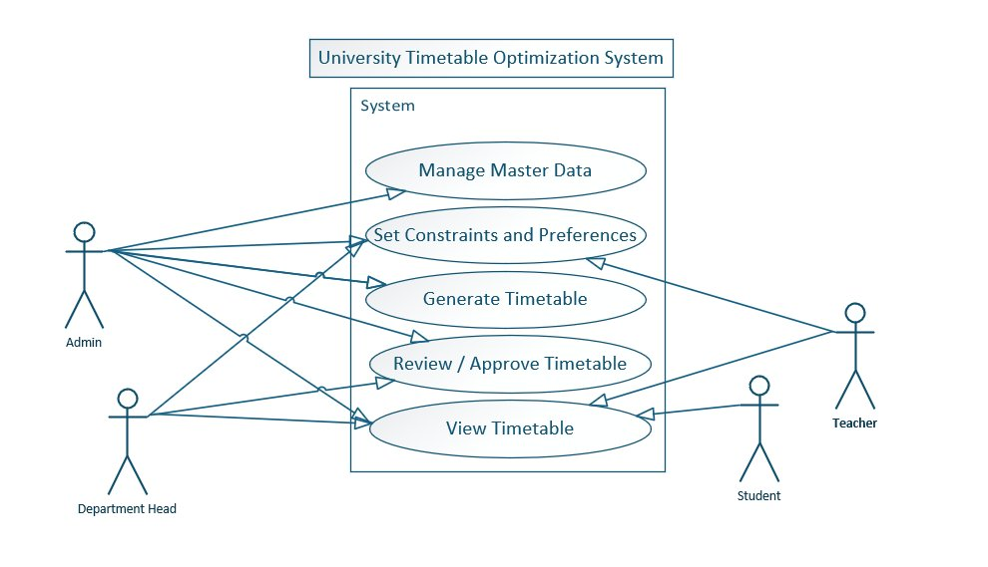
Figure 5.1 — Use Case Diagram showing UC00 and UC02 to UC15 with actor associations.

5.1.2 Exam Timetabling and System Administration Use Case Diagram
This diagram covers the Exam Timetabling module (UC16 to UC20) and System Administration use cases (UC21 to UC22).

Figure 5.2 — Exam Timetabling and System Administration Use Case Diagram showing UC16 to UC22.

5.2 Data Flow Diagrams

5.2.1 DFD Level 0 — Context Diagram
The Level 0 DFD treats UTOS as a single process (black box). External entities (actors) interact with the system through defined data flows.
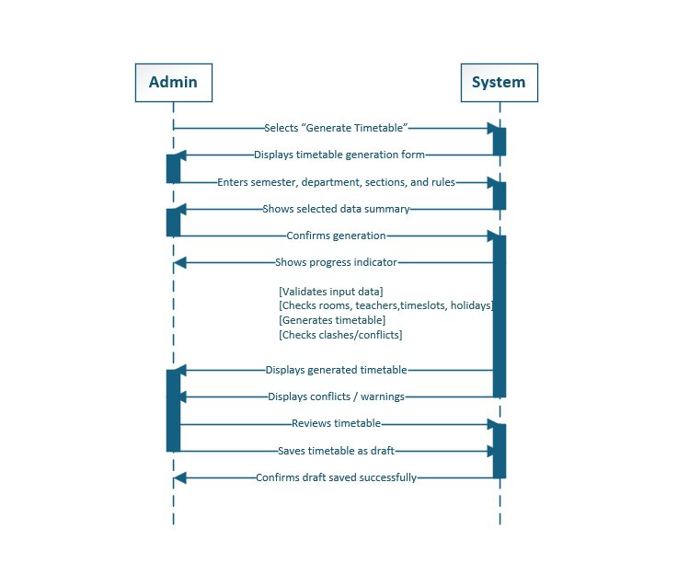
Figure 5.3 — DFD Level 0: Context Diagram showing UTOS as a black-box system with data flows to and from all six external actor groups.

5.2.2 DFD Level 1 — Major System Processes
Level 1 decomposes UTOS into its major functional processes, connected through the main data stores.
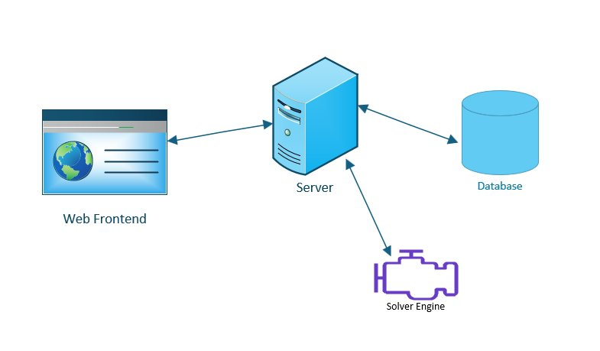
Figure 5.4 — DFD Level 1: Major system processes and data stores.

5.2.3 DFD Level 2 — Generate Timetable Decomposition
Level 2 decomposes the Generate Timetable process into its five sub-processes: data validation, constraint model building, solver execution, quality scoring, and result saving.
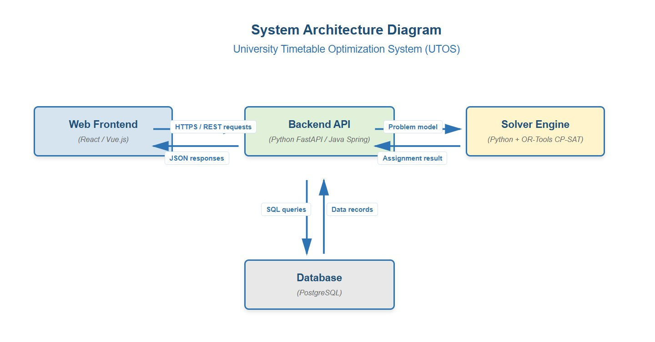
Figure 5.5 — DFD Level 2: Generate Timetable decomposition.

5.3 Swimlane Diagram — Class Timetabling Workflow
The swimlane diagram separates responsibilities among the four primary participants: Timetable Administrator, Department Coordinator, System (backend/solver), and Teacher/Student.
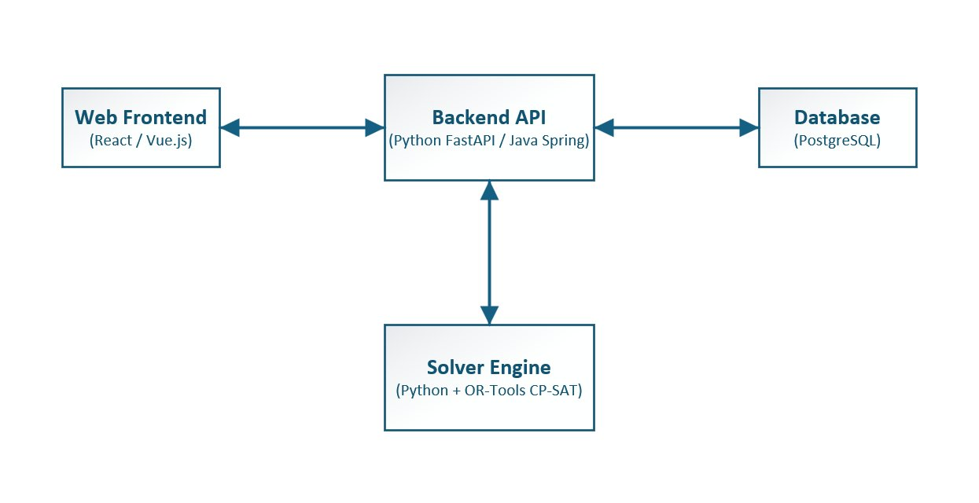
Figure 5.6 — Swimlane Diagram showing the complete class timetabling workflow from master data entry through generation, review, locking, approval, publication, and the optional change-request and re-optimization branch.

5.4 Sequence Diagram — Generate Class Timetable
The system sequence diagram for UC05 shows the interaction between the Timetable Administrator, the UTOS frontend, the backend API, the solver engine, and the database during a generation request.
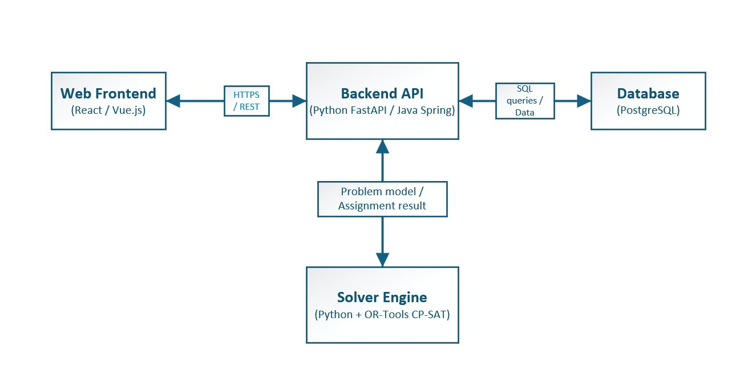
Figure 5.7 — System Sequence Diagram for UC05 (Generate Class Timetable) showing the asynchronous generation flow.

5.5 Entity-Relationship Model
The ERD covers both the class timetabling and exam timetabling modules. Core entities from the SRS are included:
- Identity and Access: User, Role — one user holds one role; role defines permissions.
- Organization: University, Faculty, Department, Batch, Section, Student — hierarchy supporting the exam student tree and class timetabling scoping.
- Resources: Building, Room, Teacher, Timeslot — Room belongs to Building; Room has capacity and room_type.
- Class Scheduling: Course, AcademicTerm, AcademicCalendar, Holiday, Constraint, Preference, TimetableVersion, TimetableEntry.
- Change and Audit: ChangeRequest, AuditLog — ChangeRequest links to TimetableEntry; AuditLog records every change with actor identity, timestamp, and old/new values.
- Communication: Notification, NotificationUser — a Notification is linked to specific users; is_read tracks the read state per user.
- Exam Module: ExamCourse, ExamSession, InvigilationAssignment — ExamSession stores confirmed exam room and time.

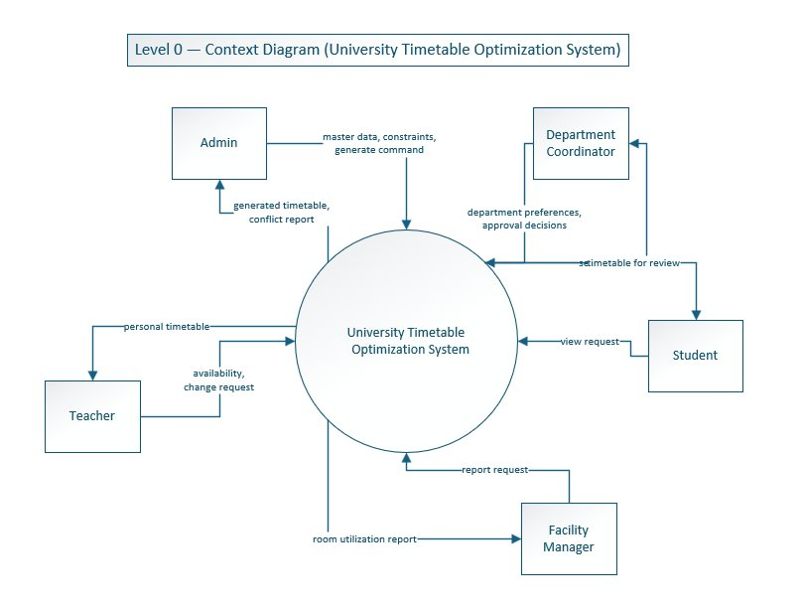
Figure 5.8 — Entity-Relationship Diagram (class timetabling baseline). The full-scope model extends this with TimetableVersion, VersionDiff, Notification, NotificationUser, AuditLog, Faculty, Department, Batch, Student, ExamCourse, ExamSession, InvigilationAssignment, and DistanceGraph entities.

5.6 System Architecture
UTOS is built as a four-layer web application. The architecture is designed with a swappable solver interface so the current custom BFS solver can be replaced by a more powerful constraint-programming engine in a future increment.
Layer | Component | Technology (v1.0) | Future Consideration
Presentation | Web Frontend | Vanilla JS/CSS (no build step) | Framework migration if needed for scale
Application | Backend API | Python stdlib (ThreadingHTTPServer) | ASGI framework for async support
Data | Database | SQLite | PostgreSQL for 1000+ concurrent users
Computation | Solver Engine | Custom BFS-based scheduler | OR-Tools CP-SAT (planned increment 9)
Infrastructure | Background Jobs | Synchronous (MVP) | Redis queue for non-blocking generation

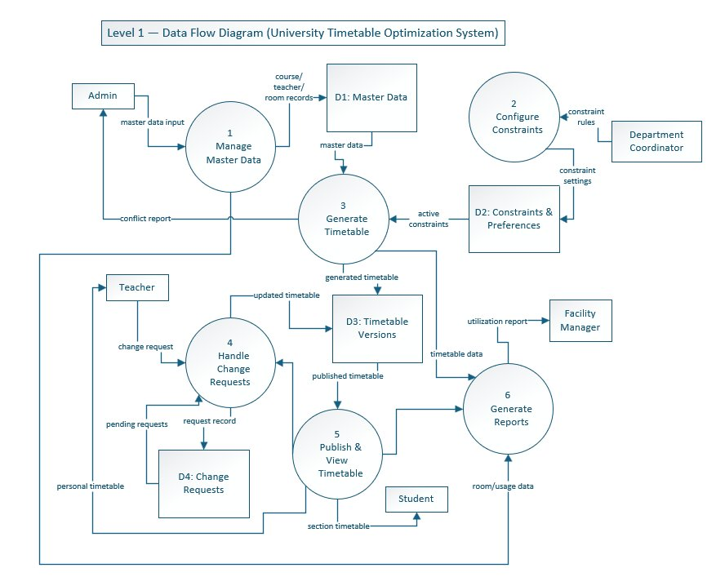
Figure 5.9 — System Architecture Diagram showing the four-layer UTOS architecture: Web Frontend, Backend API, Database, and Solver Engine.

6. UI Evidence and Implementation Screens
The screenshots in this section provide evidence that the major real use cases already have interface support in the current or prototype implementation.

6.1 Authentication and Role-Based Navigation (UC00, UC21)
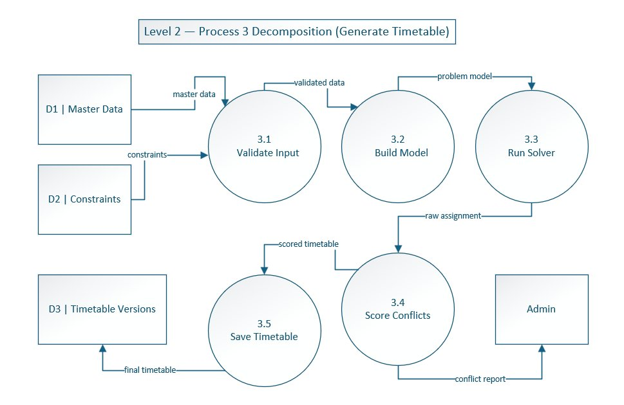
Figure 10.1 — Role-selection login screen for UTOS.

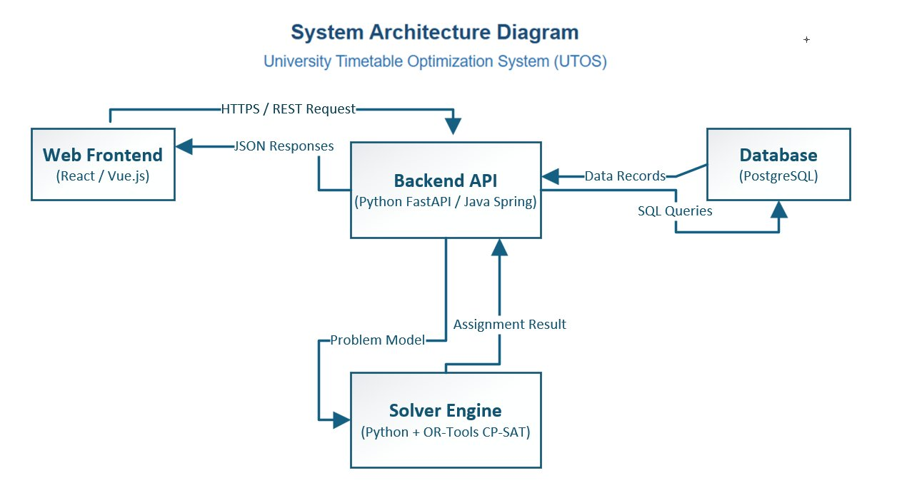
Figure 10.2 — Role-specific sidebar navigation for five user roles.

6.2 Schedule Control Center (UC05, UC06)

Figure 10.3 — Schedule Control Center dashboard before generation.

6.3 Draft Review with Conflicts and Locks (UC06, UC07)

Figure 10.5 — Draft review mode showing locked entries and conflict highlighting.

6.4 Master Data Management (UC03, UC16)
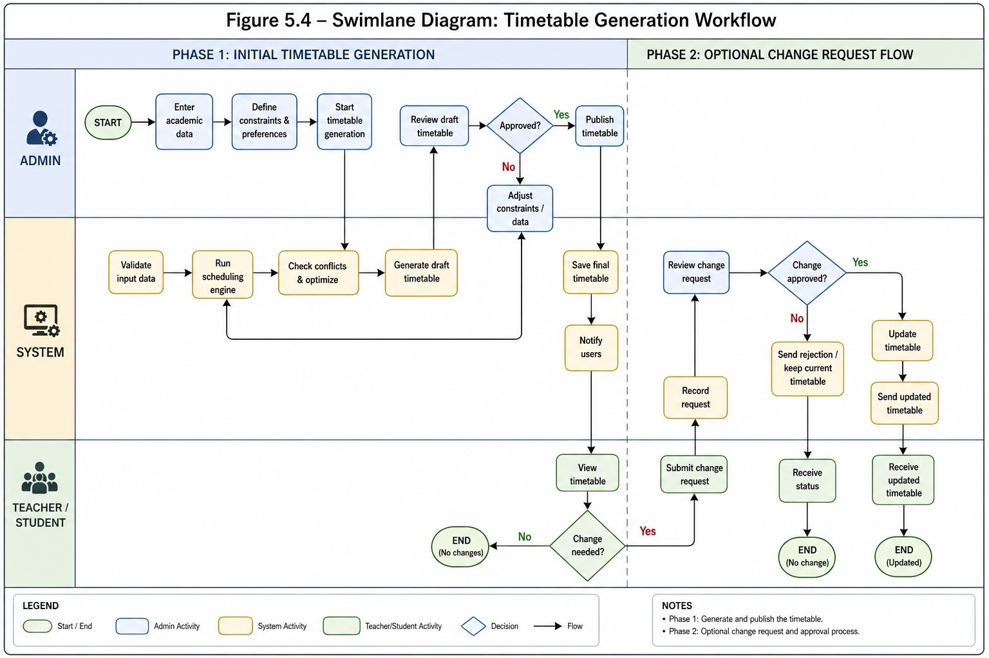
Figure 10.6 — Master Data: Teachers Management screen.

7. Traceability Matrix
The following table links each major use case to the SRS functional requirement groups it satisfies. Use cases with expanded narratives in Section 4.4 are marked with an asterisk (*).

Use Case | Module | SRS Requirement Groups | Expanded in Sec 4.4
UC00 — Authenticate and Login* | System-wide | FR-00.1 to FR-00.6c | Yes
UC01 — Maintain Organization Hierarchy | System-wide | FR-00.6a to FR-00.6d | No
UC02 — Maintain Academic Calendar | Class Timetabling | FR-01.1 to FR-01.5 | No
UC03 — Manage Master Data | Class Timetabling | FR-02.1 to FR-02.6b | No
UC04 — Define Constraints and Preferences | Class Timetabling | FR-03.1 to FR-03.15 | No
UC05 — Generate Class Timetable* | Class Timetabling | FR-04.1 to FR-04.7c, FR-00.9 | Yes
UC06 — Review Timetable Quality* | Class Timetabling | FR-05.1 to FR-05.5, FR-21.1 to FR-21.8 | Yes
UC07 — Manually Adjust and Lock Timetable* | Class Timetabling | FR-06.1 to FR-06.4, FR-07.1 to FR-07.3 | Yes
UC08 — Submit Change Request* | Class Timetabling | FR-10.1, FR-10.1a, FR-00.10 | Yes
UC09 — Approve or Reject Change Request* | Class Timetabling | FR-10.2, FR-10.3, FR-07.1, FR-00.10, FR-00.11 | Yes
UC10 — Re-optimize Timetable | Class Timetabling | FR-07.1 to FR-07.3 | No
UC11 — Publish Timetable* | Class Timetabling | FR-08.1 to FR-08.4b, FR-00.8 | Yes
UC12 — View Personal or Section Timetable | Class Timetabling | FR-09.1 to FR-09.3 | No
UC13 — Export Timetable | System-wide | FR-00.1 to FR-00.5b (Export group) | No
UC14 — Manage Notifications | System-wide | FR-00.6 to FR-00.14 | No
UC15 — Compare Timetable Versions | System-wide | FR-00.15 to FR-00.19 | No
UC16 — Manage Exam Rooms | Exam Timetabling | FR-15.1 to FR-15.4 | No
UC17 — Manage Student Hierarchy | Exam Timetabling | FR-16.1 to FR-16.4 | No
UC18 — Manage Exam Courses | Exam Timetabling | FR-17.1 to FR-17.3 | No
UC19 — Schedule Exams* | Exam Timetabling | FR-18.1 to FR-18.8, FR-19.1 to FR-19.5 | Yes
UC20 — View Exam Schedule and Invigilation Duties | Exam Timetabling | FR-19.1 to FR-19.5 | No
UC21 — Manage Users and Roles | Administration | FR-20.1 to FR-20.8 | No
UC22 — View System Reports and Audit Logs* | Administration | FR-21.1 to FR-21.8, NFR-07 | Yes

8. Conclusion
This document presents UTOS as a full-scope university timetable optimization and management platform. The improvements over the earlier class-only draft include:
- Full alignment with SRS v1.0 Full Scope, including the exam timetabling module, system-wide features, and the complete role set.
- A comprehensive use case analysis following the teacher-provided Analysis Models guidance, with high-level use cases for all twenty-three use cases and fully expanded narratives (essential + real dual flows) for eight selected use cases.
- System modeling diagrams (DFD Level 0/1/2, swimlane, sequence, ERD, and architecture) aligned with the SRS and annotated with clear explanations tied to use cases.
- UI screenshot evidence demonstrating that login, dashboard, timetable generation, draft review, master data management, change requests, reports, and publishing have interface support.
- A traceability matrix linking all use cases to the SRS requirement groups they satisfy.

8.1 Document Completeness Checklist
Deliverable | Included | Location
High-level use cases (all 23) | Yes | Section 4.3, Table
Expanded use cases with dual essential/real flows | Yes | Section 4.4 (UC00, UC05 to UC09, UC11, UC19, UC22)
Essential use cases (abstract, technology-free) | Yes | Section 4.4, each expanded UC
Real use cases (tied to UTOS UI screenshots) | Yes | Section 4.4, each expanded UC
Typical Course of Events (Actor Action / System Response tables) | Yes | Section 4.4
Alternative courses for each expanded use case | Yes | Section 4.4
Class Timetabling Use Case Diagram | Yes | Figure 5.1
Exam Timetabling and System Administration Use Case Diagram | Yes | Figure 5.2
DFD Level 0 — Context Diagram | Yes | Figure 5.3
DFD Level 1 — Major Processes | Yes | Figure 5.4
DFD Level 2 — Generate Timetable Decomposition | Yes | Figure 5.5
Swimlane Diagram — Class Timetabling Workflow | Yes | Figure 5.6
System Sequence Diagram — Generate Class Timetable | Yes | Figure 5.7
ERD / Domain Model | Yes | Figure 5.8
System Architecture Diagram | Yes | Figure 5.9
UI Screenshots | Yes | Section 6
SRS Alignment and Requirements Summary | Yes | Section 3
Traceability Matrix (UC to SRS requirements) | Yes | Section 7
Process Model with increments | Yes | Section 2

References
The following sources informed this document:
- SRS_v1.0_Full_Scope.md — Full-scope Software Requirements Specification for UTOS (primary source of truth).
- 04_Analysis-Models.ppt — Teacher-provided Software Engineering Analysis Models guidance covering use case types, DFDs, and domain modeling.
- UTOS_Full_Scope_Use_Case_Analysis_with_UI.docx — Earlier use case analysis document used as a baseline for this revision.
- User-supplied screenshots and diagrams — UI evidence, ERD, DFDs, swimlane, sequence, process model, and architecture figures.
- Larman, C. (2004). Applying UML and Patterns. Prentice Hall. — Methodology source for use case classification and expanded use case format.
- Jacobson, I. et al. (1992). Object-Oriented Software Engineering: A Use Case Driven Approach. Addison-Wesley.
- Bettinelli, A. et al. (2015). An overview of curriculum-based course timetabling. TOP.
- Google OR-Tools CP-SAT Documentation — Reference for future solver upgrade.

